**Assignment 4**

**Kolby Sarson – 104232327**

1. Illustrated in the following is a sequence diagram designed to accomplish the “Manager” use case for a manager of the online bookstore system to change the role of a user, to change the price of a book, or to add a new book. Discuss what you should do if the corresponding “Manager” use case in OOA has one more feature (e.g., for the manager to check the list of orders) than the sequence diagram does. Alternatively, what should you do if the “Manager” use case (in OOA) has one more feature than the corresponding requirement (in reception) does? Explain your answers.

If the Manager use case in OOA has one more feature than the sequence diagram does, it would need to be implemented into the sequence diagram as an Alternative Flow. There may also need to be another class involved if the manager has to interact with the order item list, as specified in the example. If the Manager use case has one more feature than the corresponding requirement does, it can be implemented into the sequence diagram but is not a necessary requirement. If the feature can be added into the sequence diagram in the proper order of execution, then it may be useful in designing the system. Though since it has more features than requirements, the feature would not be a necessary implementation into the sequence diagram.

1. Discuss if generalization relationship between classes can be illustrated in a sequence diagram. If yes, use an example to explain. If not, explain why not.

No, generalization relationships between classes cannot be illustrated in a sequence diagram. Each generalized actor will need additional sequences using the respective specific actor. This is because these diagrams intended to show events happening in a strict sequence and these actors may perform functions at different times. They would not be illustrated as generalized and related objects in the sequence diagrams because they would still have different functions and actions to perform.

1. Use Visual Studio to reproduce the sequence diagram as illustrated below. For simplicity, you may choose to ignore most of the commentary notes. However, at least one commentary note must be included in your diagram where the initials "XY" need to be replaced by your own initials. In preparation for the next question, your sequence diagram also needs to create a sub-sequence diagram by first separating the interactions in the light-blue box (upper-left in the diagram) from the main sequence diagram and then refer the sub-sequence diagram in the main diagram.

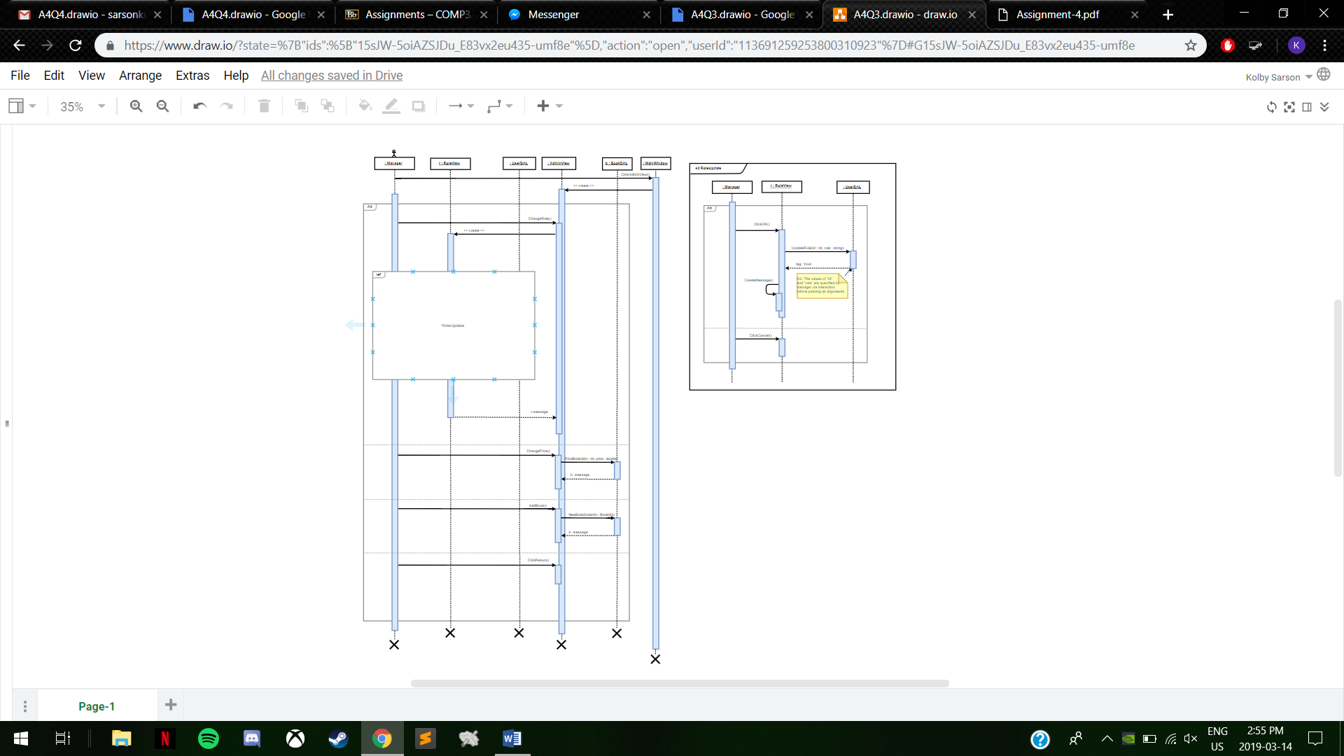

1. Use Visual Studio to derive a class diagram according to your sub- and main sequence diagrams. When completing the class diagram, make sure that not only the right class names but also adequate attributes, relationships, visibilities, parameters, and multipliers need to be included to make the class diagram correct and complete.
   1. First create a class diagram according to the sub-sequence diagram; and then.

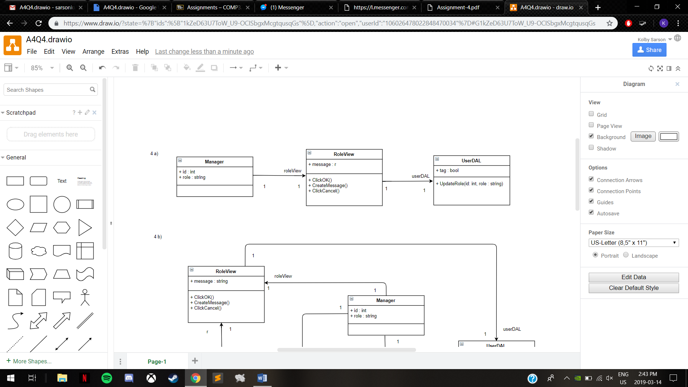

* 1. 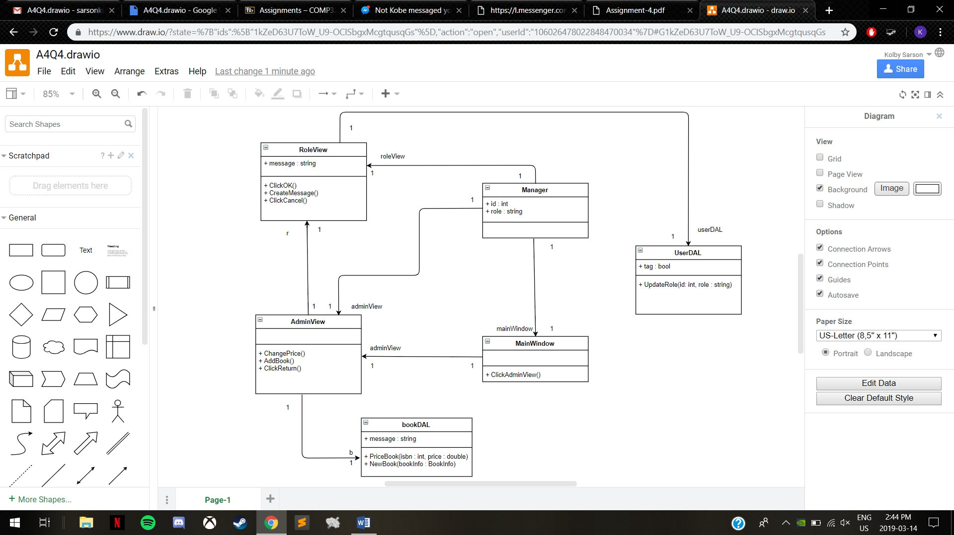Update your class diagram according to the main sequence diagram.